Forensicare guideline for submissions to the Operational Research Committee
_____________________________
May 2025

Introduction
All research involving consumers, staff, or records of Forensicare must be approved by the Operational Research Committee (ORC). Clinical audit or service evaluation projects that involve direct collection of data or accessing consumer or staff information where the intent is to disseminate the results externally (e.g., as a conference presentation or peer reviewed publication) must also be approved by the ORC. As must conference presentations disseminating Forensicare consumer or staff data.

This process is separate from a Human Research Ethics Committee approval.

The Forensicare Operational Research Committee (ORC)
The ORC acts as the main gateway for researchers wishing to gain approval to conduct research involving Forensicare consumers, staff, or resources. The ORC reviews all research project, quality appraisal project and conference presentation proposals. In addition, the ORC reviews the progress of each approved project.
The ORC reports to the Forensicare Board. The Forensicare Research Department provides research and administrative support to the ORC. Proposals submitted to the ORC are reviewed out of session.
Membership of the ORC includes:
- Executive Director of Clinical Services (Chair)
- Executive Director of Prison Operations
- Executive Director of Community Operations
- Executive Director of Hospital Operation
- Director of Nursing
- Director of Psychological Services
- Director of Allied Health
- Professor of Forensic Psychiatry
- Chief Occupational Therapist
- Chief Lived Experience
- Up to three additional research active clinicians
- Forensicare Research Department (Manager and Fellow)
The ORC reviews proposals against the following factors:
- The overall merit of the research
- Alignment of outcomes with the Forensicare strategic plan priorities & Forensicare strategic research priorities (see below)
- The possible benefits of the research in relation to healthcare/service development
- The operational burden of the project on the intended research site
- The resource burden in relation to staff time
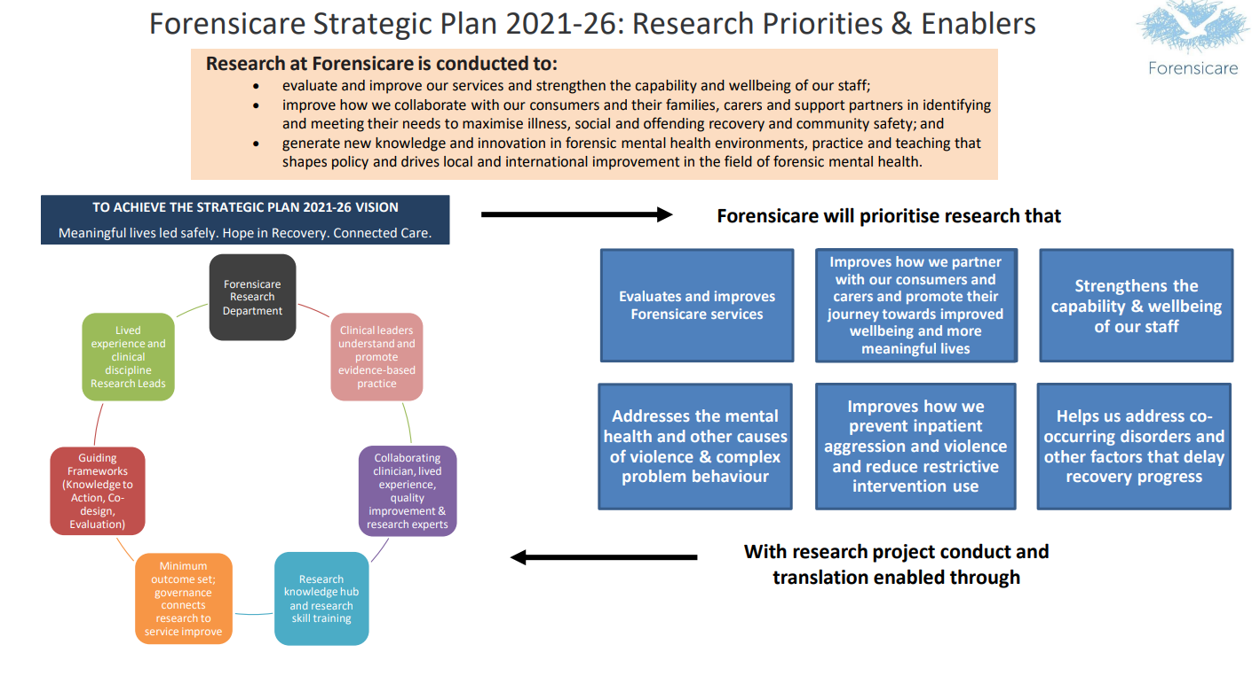
The Forensicare ORC is not a Human Research Ethics Committee and cannot provide ethical approval for the conduct of human research at Forensicare

Human Research Ethics Committee (HREC) Approval
Where human subjects (e.g., consumers, staff, carers) are involved, research must conform to the National Statement on Ethical Conduct in Human Research 2023. This is a requirement of the National Health and Medical Research Council Act 1992. The 2023 National Statement may be found at:
National Statement on Ethical Conduct in Human Research 2023
See also:
Ethical considerations in quality assurance and evaluation activities | NHMRC

What is human research?
Human research is conducted with or about people, or their data. Human participation in research is therefore to be understood broadly, to include the involvement of human beings through:
- Taking part in surveys, interviews or focus groups
- Undergoing psychological, physiological, or medical testing or treatment
- Being observed by researchers
- Researchers having access to their personal documents or other materials
- Access to their information (in individually identifiable, re-identifiable or nonidentifiable
form) as part of an existing published or unpublished source or database.

The term ‘participants’ is therefore used very broadly in the National Statement to include those who may not even know they are the subjects of research; for example, where the need for their consent for the use of their data has been waived by a HREC.

When is HREC approval needed?
A judgement that a human research proposal meets the requirements of the National Statement and is ethically acceptable must be made before research can begin.
- All research involving consumers, staff, or records of Forensicare must be approved by a relevant HREC.
- All clinical audit and service evaluation projects involving consumers, staff, or records of Forensicare, where the intent is to disseminate the information externally must be approved by a relevant HREC.

The relevant HREC should be of the organisation which would bear liability (generally the academic institution of the Principal Investigator). If no HREC would be responsible, application should be made to the Department of Health Human Research Ethics Committee, as Forensicare is a statutory authority reporting to the Minister for Health:
Department of Health Human Research Ethics Committee

The Department of Justice requires that any research involving their clients also requires approval of the Department of Justice HREC:
Justice Human Research Ethics Committee | Department of Justice and Community Safety Victoria

Forensicare ORC submission & approval process: Research project
The outlined submission process must be followed before a research project can commence at Forensicare:
- You can contact the Forensicare Research Department for advice about conducting research, clinical audits, or service evaluations at Forensicare, via this link research@forensicare.vic.gov.au
- Supply documents for ORC review:
  - Forensicare Research Proposal Protocol form
  - Completed application form for the relevant HREC
  - Copies of any instruments to be used in the study (e.g., questionnaires, interview questions, audit forms)
  - Conditional approval from Health Information Services for use of data (if necessary)
- Feedback about the submitted Forensicare Research Proposal Protocol form will usually occur within five business days. The ORC may request edits or require clarification or more information about the proposal. A formal letter describing the outcome of the proposal will be sent to the principal investigator.
- Submit required documents in accordance with the relevant HREC (external to Forensicare). Once HREC approval has been obtained, the principal investigator must forward a copy of the written approval to the Forensicare Research Department.

- To enable Forensicare to monitor and report on research conducted within the organisation; all investigators are required, as a condition of approval, to provide brief annual progress reports upon request. Applicants will be contacted by the Forensicare Research Department in July each year to obtain a progress report or final report as applicable. In addition, as a condition of approval applicants are required upon request to disseminate the results of their research to Forensicare staff, consumers, and significant others (as applicable) at annual research dissemination seminars and/or embedded into summary news stories.
Failure to comply will lead to the withdrawal of approval and suspension of the research project. In addition, any adverse events need to be notified promptly to the Operational Research Committee as well as the approving HREC.

Please contact the Forensicare Research Department for advice at any stage
research@forensicare.vic.gov.au

Forensicare ORC submission & approval process: Conference presentations
The outlined submission process must be followed before providing a conference presentation disseminating Forensicare consumer or staff information:
- Complete a submit a Forensicare Conference Presentation Proposal form and submit to the Forensicare Research Department research@forensicare.vic.gov.au
- Feedback about the submitted Forensicare Research Proposal Protocol form will usually occur within ten business days. The ORC may request edits or require clarification or more information about the proposal. A formal letter describing the outcome of the proposal will be sent to the principal investigator.

Figure 1: Forensicare Organisational Chart (modified)

